

Laboratory Manual
for
SC1003
Introduction to Computational Thinking and Programming

Practical Exercise #2:
Basic Python Programming

SCHOOL OF COMPUTER SCIENCE AND ENGINEERING
NANYANG TECHNOLOGICAL UNIVERSITY

Learning Objectives
The manual provide information and practical exercises to let you learn how to write simple Python programs through hands-on coding exercises on the Raspberry Pi. It also shows how variables and data types can be useful when coding program.

Intended Learning Outcomes

At the end of this exercise, you should

know the basic structure of a Python program.

be able to make use of variables and different data types in the program.

Equipment and accessories required
- Raspberry Pi 3 Model B (RPi3) board with Sense HAT add-on display module/board.
- A USB power source to power the RPi3 board (E.g. Power Bank, Adaptor or USB port of a desktop computer).
- A computer (desktop PC or notebook) with Ethernet port and cable for remote access of RPi3. Software (open source) to be installed on the computer – PuTTY, VNC Viewer, ‘MS Remote Desktop Connection’ and WinSCP
_________________________________________________________________________

1. Basic Python Program
A program is basically a sequence of instructions that get executed in the order that it is coded. Writing (or coding) a program is to create the sequence of instructions according to your design and comply with the rules of the chosen programming language, which is Python in this course. A good programming style is to code the program such that it easy to be read and understood by other people.

The following is a simple program that should be intuitive obvious on what it is doing.

Line
1

2
3

4
5

6
7
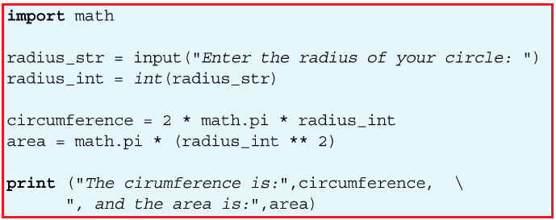

Ways to edit and run the exercises: (Choose either option 1 or Option 2)

- Use cloud9 IDE
Connect RPi to PC, run “Putty” and start the Cloud9 IDE (refer to Practical Exercise manual #2 ), and use PC web browser to access cloud9 IDLE. Check that cloud9 IDE is configured for Python 3 – See Appendix A below for the procedure.

Or

- Use “Remote Desktop Connection”
Connect RPi to PC, run “Remote Desktop Connection” on PC desktop to connect to Rpi, and run the Python 3 IDLE within Rpi directly. Refer to Appendix B for steps.

Coding Exercise 2a

- Key in the above program code. Remember to save your program file in the folder of your group
- Run the program and observe its output (which is shown in ….)

‘Analysis’ of the program code
Line 1 in the code is to import a mathematic module, math that contains some commonly used code (in the form of functions) and constants for solving mathematical problems.
  - A module is a file that contains program code written by someone else which you can ‘re-use’ by importing it into your program using the keyword import.
  - This is an example of the Abstraction concept used in the Computational thinking, which is to hide the underlying detail of the code from the user.
(Side note: It turns out that this math module is written in C programming language)

Line 2 is a python program assignment statement that involve a variable, a function and the assignment symbol.
- On the right side of the assignment symbol ‘=’, input()is a built-in small Python program known as a function.
- It prints the characters indicated in the parentheses and then waits for you to input character(s) through the keyboard.
- Once you type the sequence of character(s) through the keyboard and press the Enter key, the function stores the sequence of characters somewhere in the memory, and assign this sequence of character to the variable radius_str, which is on the left side of the ‘=’ symbol.
- The sequence of characters is known as a string in computing. That is the data type of this variable is string (str n short).
- Hence the variable radius is appended with _str to make it explicitly clear to the reader that this variable is a string.

Line 3 is another python program assignment.
- int is a built-in function that reads the value of variable radius_str and returns the integer value corresponding to the variable (What happen if you enter something that cannot be convert to integer? Try this by running your program,)
- The statement then assigns the integer value to the variable radius_int.
- Again it is a good practice to make it clear to the reader that this variable is of data type integer by appending it with _int.

Line 4 is a statement to calculate the circumference of a circle using the formula as shown, and assign it to the variable circumference
- The value of the pi is available through the math module as math.pi.

Line 5 is a statement to calculate the area of a circle as shown and assign it to the variable area.

Line 6 is to use the built-in function print to display the quoted string, follows by the value of the variable circumference onto the monitor.
- The backslash character ‘\’ indicates that the statement is to continue onto the next line, for situation when the statement is too long to fix on one line.

Line 7 is the continuation of the print statement.

2 Displaying messages on Sense HAT Add-on Board

Now that you have learnt the basic structure of a program, you will apply the knowledge to code a program to display and manipulate the text shown on the Sense HAT (SH) add-on board on the RPi using functions provided by the Sense Hat module (also refer to as software library).

2.1 The first thing to do when coding the program for the SH board is to import the module that contains the various functions required to operate the SH board. This is done by using the following two statements.

from sense_hat import SenseHat
sense = SenseHat()

This is similar (but not the same) to create a variable and assign it with certain initial value - but the sense here is known as an object in Python. (And of course you can use other name of your choice.)

Side Note (for those who are curious - the following provide a bit more detail about what the two lines of code are about):
Slightly different from the math module you saw earlier, here you first import a ‘class’ definition SenseHat from the sense_hat module. A ‘class’ contains code that describe the functions (more correctly, it is known as methods in Python) that can be used by our program.

The way to use the class definition is you first create an object and initialize it to have the characteristics of the class. In this case, we create an object with the name sense and assign it to have the SenseHat class. This is described as to instantiate sense to be a SenseHat object.

This is somewhat similar (but not exactly the same) to when you create a variable b , you can’t use it before you assign a value to it. (see below example that was entered in IDEL3 to illustrate the point)

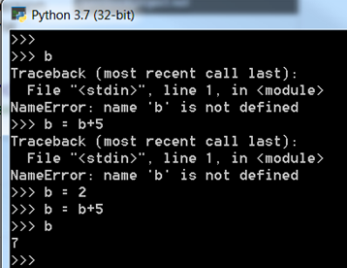

2.2 With the object sense just created, you can now use it with the various commands (i.e. functions, or methods) provided by the sense_hat module. The following are some of these commands that you can use to manipulate the display on the SH board.

- To display a message on the SH board, you can use the command show_message()as follows (which you had done several time in earlier exercises):
sense.show_message(“Hello”)
- You can use the command set_rotation() to change the orientation of the display shown on the SH board using one of the parameters (0, 90, 180, 270).

sense.set_rotation(180)

- You can change how the message is displayed by adding extra parameters to the show_message command.

- text_colour to change the colour of the message, such as

sense.show_message(“Hello”, text_colour = (255,255,0))

- back_colour to change the background colour of the message

sense.show_message(“Hello”, back_colour = (255,0,0))

- scroll_speed to change the speed of scrolling the message (default value is 0.1)

sense.show_message(“Hello”, scroll_speed = 0.5)

- You can use the command sense.clear() to clear the display on the SH board, or set it to a specific colour.

sense.clear() or sense.clear(100,100,100)

Coding Exercises 2b:
- Basic Program Structure
- Write a program to display the message “This is fun!” on the SH module.
- Change the orientation of the message by 180 degree.
- Add the text_colour parameter to you message as shown in example above.
- Change the 3 numbers used in the text_colour to various values and observe its effect.
- Things to ponder (and ask your friend sitting beside you):
- What do the 3 numbers mean?
- What is the maximum value you can use for each of the number, and what does it imply?
- Change the background of the message such that the message is in yellow colour with the back ground in blue colour.
- Change the speed of the display using the scroll_speed parameter.

- Use of variables
Now create three variables, color_msg, color_bg, speed in your program such that you can display messages using the statement as follows.

sense.show_message(“I got it!”, text_colour = color_msg, \
back_colour = color_bg, \
scroll_speed = speed)

- Challenge - Use of data types
Add the input() function to your program to allow the user to choose different colours and speed for your message display.

Tip: You may want to use the built-in print() function to print messages in the console when debugging your code.

Appendix A – Configure Cloud9 IDE for Python 3
Python programming language was conceived in the late 1980s, and has since gone through several revisions, with version 3 being the latest (specifically, version 3.7 that was released on June 27, 2018). (https://en.wikipedia.org/wiki/History_of_Python). But Python 2 (2.7) can still be found in many existing/legacy applications.
There are plenty of differences between version 2 and version 3 of the Python language. Two of the differences you will notice when you code programs in this course are the print() and input() functions.
- In Python 2, the print statement is written as print “Hello world”, while in Python 3, print statement is replaced as a function and is written as print (“Hello world”).
- In Python 2, the input()function evaluates the data it receives and returns the data type based on what it ‘thinks’ it should be. In Python 3, input() function always returns the data as str (i.e. string) data type object.

Cloud9 IDE supports both Python 2 and Python 3, but it is obvious that we should learn the latest, which is Python 3. As such, you will configure Cloud9 IDE for Python 3 in this course, using the steps as described below.

i) Select the Preferences option under the Cloud9 menu

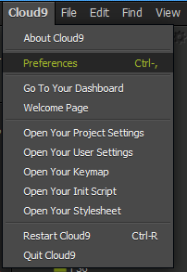

ii) The Preferences window pane will be shown. Look for the Python Version setting.

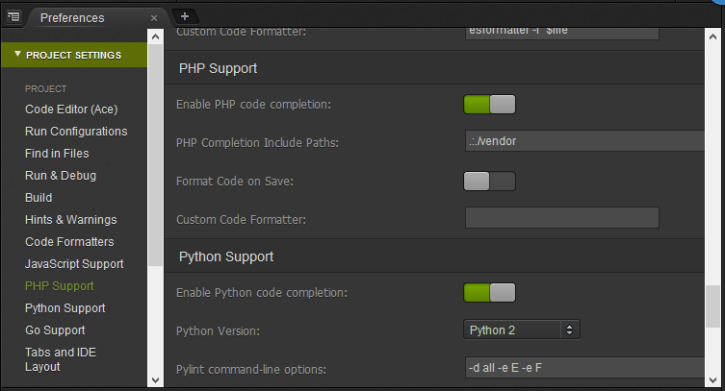
iii) If the Python Version is shown as Python 2, change it to Python 3.

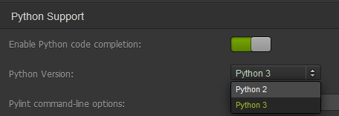

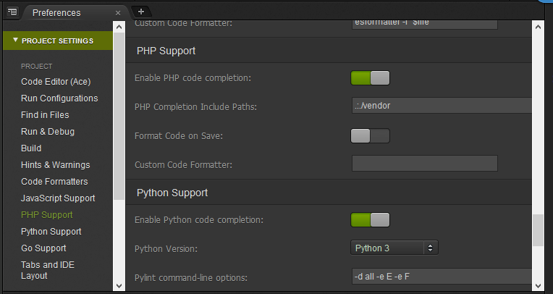

iv) In addition, when you later run your program, check that the setting for Runner is set to Python (and NOT Python 2 ).

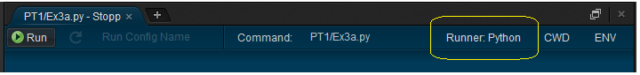

Appendix B – “Remote Desktop Connection” connection to Rpi

1 | Launch “Remote Desktop Connection” from PC desktop |  | 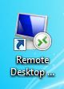
2 | Use IP address 11.11.11.11  Click “Yes” on the Identity pop up window |  | 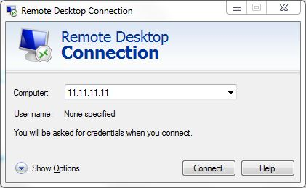
3 | Use the following to login to Pi :  Session : Xorg  Username : pi  Password : raspberry |  | 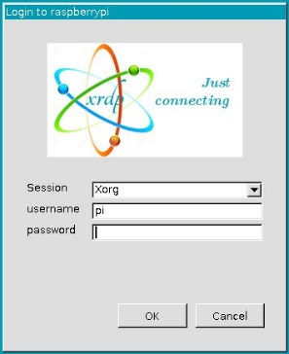
4 | Click on the Resize Button on the Top blue bar to resize the remote desktop for ease of accessing the PC and remote session together  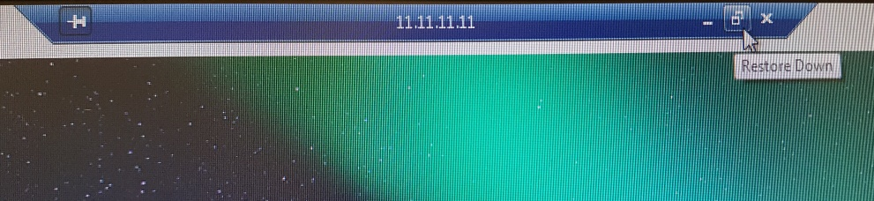
5 | You could use “right click” copy and paste between PC and the raspberry remote desktop session for easy file transfer and even copy/paste codes  Remarks : right click copy/paste will not work on folder | 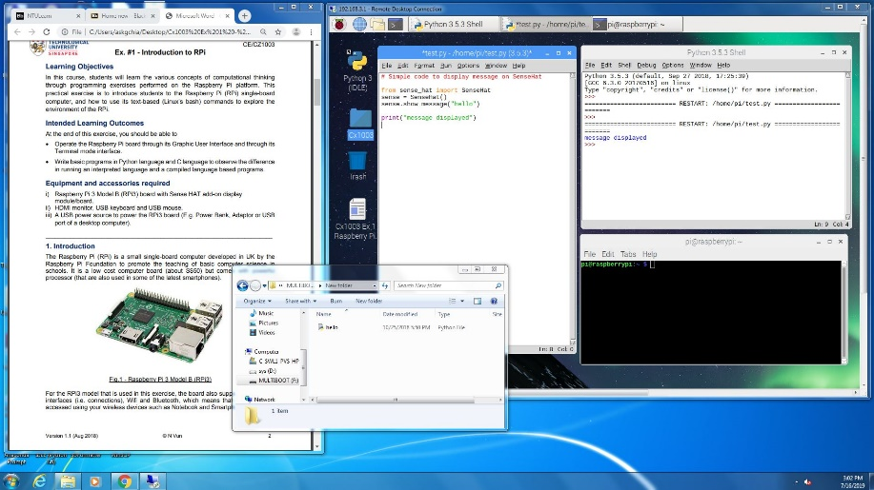

Appendix C - Python IDLE within “Remote Desktop Connection”

To use Rpi Python IDLE within Remote Desktop session
1 | Launch “Python3 (IDLE)” from Raspberry Pi desktop  Alternatively you could launch from menu bar, Programming, Python 3(IDLE) | 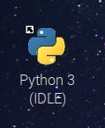
2 | Click “File” “New File” to open the Python IDLE editor  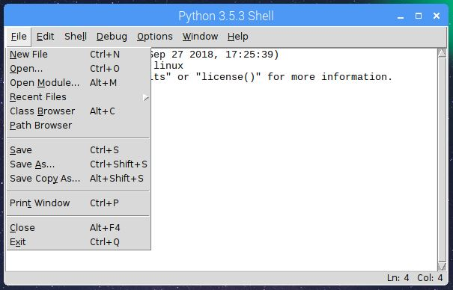
3 | To execute the code, select “Run” “Run Module F5” from the editor menu bar, this will invoke a new python shell window where you can interact with the game. (Remarks : you can use the <F5> function key to execute the code as well)  Keep both the editor and python shell side by side for ease of use  